**Introduction To Computing**

**What is Computer?**

* is a **programmable** device that stores, retrieves, and processes data. The term "computer" was originally given to humans (human computers) who performed numerical calculations using calculators, such as the ***abacus*** and ***slide rule***. The term was later given to a me mechanical device as they began replacing the human computers. Today's computers are electronic devices that accept data (*input*), ***process*** that data, produce *output*, and store (***storage***) the results.

**Destop Computer**

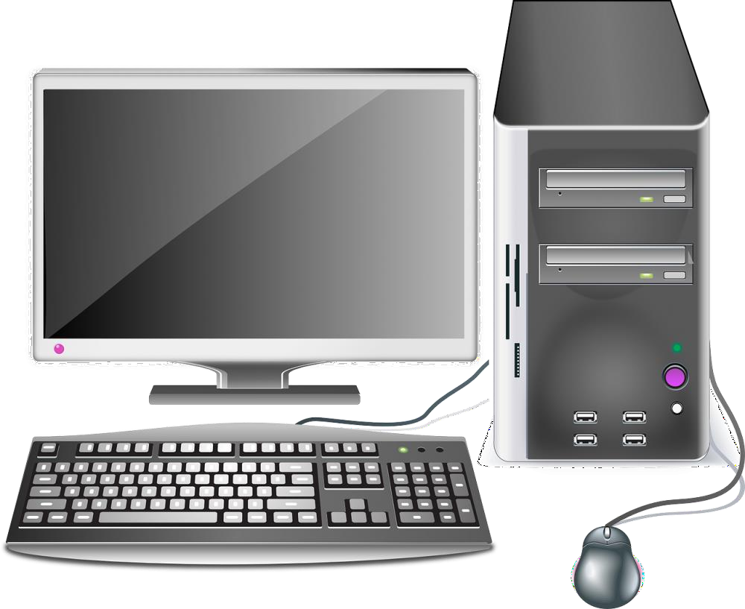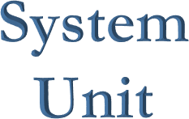

**Monitor**

- is an output device that displays information in pictorial form.

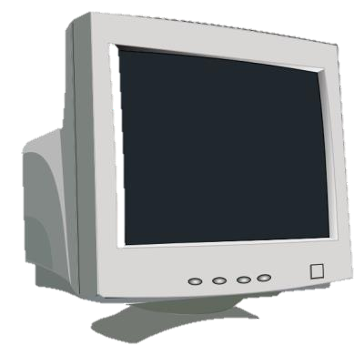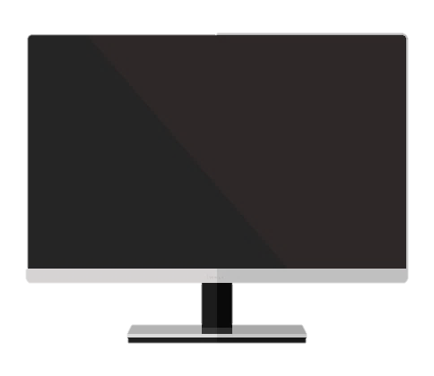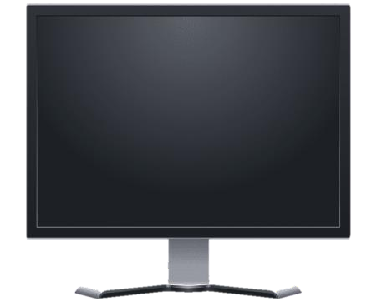

**Types of Monitor**

**CRT** – Cathode Ray Tube

**LED** – Light Emitting Diode

**LCD** – Liquid Crystal Display

**Computer Keyboard**

* is one of the primary input devices used with a computer. Similar to an electric typewriter, a keyboard is composed of buttons that create letters, numbers, and symbols, as well as other functions.

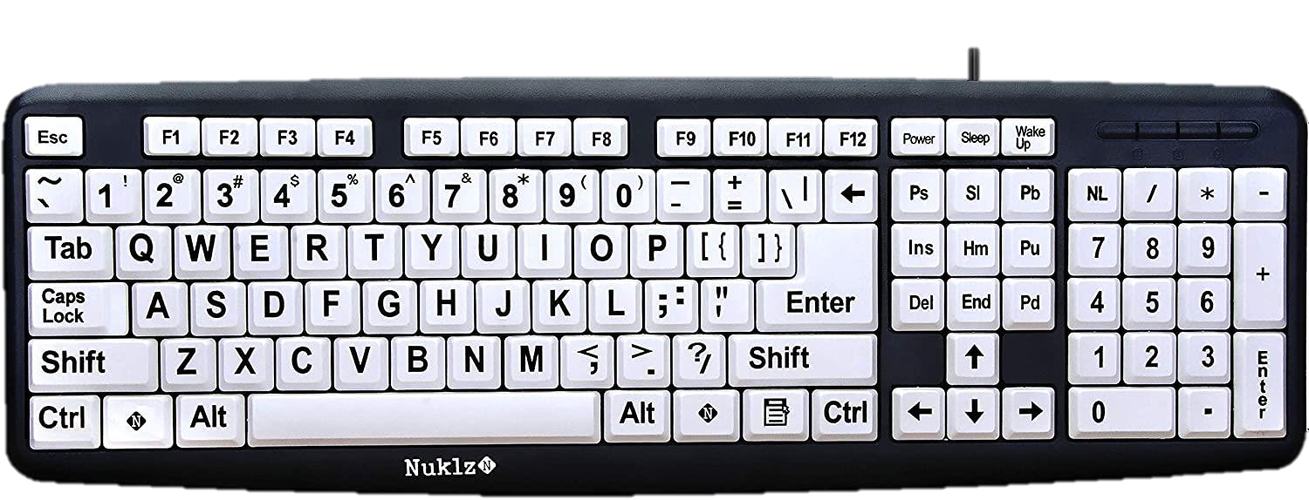

**Computer Mouse**

- is a handheld hardware input device that controls a cursor in a **GUI (Graphical User Interface)** and can move and select text, icons, files, and folders on your computer.



**System Unit**

- Alternatively referred to as a box, main unit, and system box, a system unit is the case that contains all the main parts of a computer. Below is a picture of a computer with each of the main components that help make up a computer.

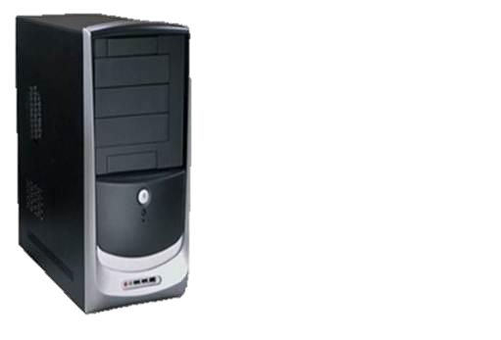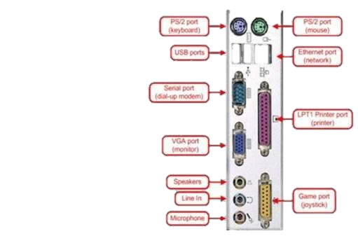

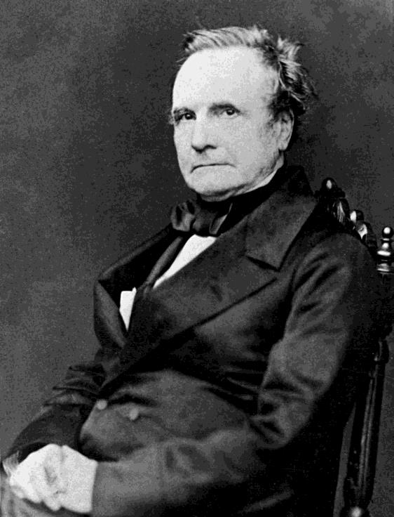

**Charles Babbage**

* A mathematician, philosopher, inventor and mechanical engineer, Babbage originated the concept of a digital programmable computer.
* Father of the computer

**Generations of Computer**

**First Generation** – It uses **vacuum tubes**.

**UNIVAC** – Universal Automatic Computer

**ENIAC** – Electronic Numerical Integrator and Computer

**EDVAC** – Electronic Discrete Variable Automatic Computer

**EDSAC** – Electronic Delay Storage Automatic Calculator

**Second Generation** – It uses **transistors**.

**Third Generation** – It uses **Integrated circ**uits.

**Fourth Generation** – It uses **Microprocessor**.

**Fifth Generation** – based on **Artificial Intelligence**.

**Components of Computer**

**Software** – The application or programs installed on a computer system.

**Examples**:

* **Microsoft office**
  + MS Word
  + MS Excel
  + MS Powerpoint
* **Browsers**
  + Google Chrome
  + Microsoft Edge
  + Mozilla Firefox

**Hardware** – The physical or tangible components of a computer system.

**Examples:**

* Hard Disk Drive
* Complementary Metal-Oxide Semiconductor
* CD/DVD Drive
* Motherboard
* Random Access Memory
* Etc.

**Peopleware** – “User”

**The Objectives**

* Recognize the importance or computer literacy
* Define the term. computer
* Identify the components of a computer
* Discuss the advantages and disadvantages of using computers
* Recognize the purpose of a network
* Discuss the uses of the Internet and World Wide Web
* Distinguish between system software and application software
* Describe the categories of computers
* Identify the elements of an information system Describe the various types of computer users
* Discuss various computer
* applications in society

**World of Computers**

A World of Computers

What is **computer literacy** (digital literacy)?

* Current knowledge and understanding of computers and their uses
* Computers are everywhere

**Information Processing Cycle**

What is the information processing cycle?

* **Input**
* **Process**
* **Output**
* **Storage**
* **Communication**

**Input Device**

What is an input device?

* Hardware used to enter data and instructions

**Output Device**

What is an output device?

Hardware that conveys information to one or more people

**System Unit**

What is the system unit?

* Case that contains the electronic components of the computer that are used to process data

**Storage**

What is storage?

* Holds data, instructions, and information for future use

**Storage media**

* Physical material on which data, instructions, and information are stored

**Storage device**

* Records and retrieves items to and from storage media

**Storage**

What is a USB flash drive?

* Portable storage device
* SmaII and lightweight enough to be transported on a keychain or in a pocket
* The average USB flash drive can hold about 2 billion characters

**Storage**

What is a hard disk?

* Provides greater storage capacity than a USB flash drive
* Most are housed inside the system unit

**Advantages of using computers**

What are the advantages of using computers?

* Speed
* Storage
* Reliability
* Consistency
* Communications

**Disadvantages of using computers**

What are the disadvantages of using computers?

* Violation of Privacy
* Public Safety
* Impact on Labor Force
* Health Risks
* Impact on Environment

**Networks and the internet**

What is a network?

Collection of computers and devices connected together, often wirelessly

* Used to share
  + Resources
  + Hardware devices
  + Software programs
  + Data
  + Information
    - Saves time and money

**Networks and the internet**

What is a server?

* A server controls access to resources on a network
* Clients, or workstations, request resources from the server

**Networks and the internet**

What is the Internet?

* Worldwide collection of networks that connects millions of businesses, government agencies, educational institutions, and individuals

**Networks and the internet**

Why do users access the Internet?

* Communications
* Research and Information
* Shopping
* Banking and Investing
* Classes
* Entertainment
* Download Music
* Share Information

**Networks and the internet**

What is the Web?

* Billions of documents, called **Web pages**, available to anyone connected to the Internet
* A Web site is a collection of related Web pages
* You can share information on a social networking Web site or a photo sharing community
* A podcast is recorded audio stored on a Web site that can be downloaded
* A Web page contains
* text, graphics, audio, video, and links to other Web pages
* A blog consists of text-stamped articles in a journal format

**The Objectives**

* Recognize the importance of computer literacy
* Define the term, computer
* Identify the components of a computer
* Discuss the advantages and disadvantages of using computers
* Recognize the purpose of a network
* Discuss the uses of the Internet and World Wide Web
* Distinguish between system software and application software
* Describe the categories of computers
* Identify the elements of an information system
* Describe the various types of computer users
* Discuss various computer applications in society

**Computer Software**

What is software?

* Consists of a series of instructions that tells the computer what to do and how to do it
* Also called a program

**Computer Software**

What is a graphical user interface (GUI)?

* Allows you to interact with the software using text, graphics, and visual images such as icons
* Controls how you enter data and instructions and how the screen displays information

**Computer Software**

What is system software?

* Program that control or maintain the operations of the computer and its devices
* **Operating System (OS)** is a set of programs that coordinates all activities among computer hardware devices
* **Utility Programs** allow the user to perform maintenance-type tasks usually related to managing a computer, its devices or its programs

**Computer Software**

What is application software?

Programs designed to make users more productive

* Word Processing
* Spreadsheet
* Database
* Presentation Graphics

**Computer Software**

What is a **programmer**?

* Someone who develops software
  + **Programmer** writes the instructions to direct the computer to process data into information

**Categories of Computers**

What are the categories of computers?

* Personal Computers (desktop)
* Mobile Computers and Mobile Devices
* Game Consoles
* Servers
* Mainframes
* Supercomputers
* Embedded Computers

**Personal Computers**

What are the two most popular styles of personal computers.

* PC and compatibles use the Windows operating system
* Apple Macintosh usually uses the Macintosh operating system (Mac OS X)

**Personal Computers**

What is a desktop computer?

* Designed so all of the components fit entirely on or under a desk or table

**Mobile Computers and Mobile Devices**

What is a notebook computer?

* Portable, small enough to fit on your lap
* Also called a laptop computer
* Usually more expensive than a desktop computer with equal capabilities

**Mobile Computers and Mobile Devices**

What is a Tablet PC?

* Resembles a slate
* Allows you to write on the screen using a digital pen
* Especially useful for taking notes

**Mobile Computers and Mobile Devices**

What are mobile devices?

* Small enough to carry in a pocket
* Internet-enabled telephone is a "smart phone"

**Mobile Computers and Mobile Devices**

What is a handheld computer?

* Small enough to fit in one hand
* Used by mobile employees such as meter readers and delivery people

**Mobile Computers and Mobile Devices**

What is a personal digital assistant (PDA)?

* Provides personal organizer functions
* Calendar
* Appointment book
* Address book
* Calculator
* Notepad

**Consoles**

What are game consoles?

* Mobile computing device designed for single-player or multiplayer video games

**Servers**

What types of servers are there?

* A **server** controls access to network resources and provides centralized storage
* **Mainframe** Very powerful, expensive computer that supports thousands of connected users
* **Supercomputer** The fastest, most powerful, most expensive computer. Used for applications requiring complex mathematical calculations

**Embedded Computers**

What is an embedded computer?

* A special-purpose computer that functions as a component in a larger product

**Elements of an Information System**

What are information system elements?

* Hardware
* Software
* Data
* People
* Procedures

**Examples of Computer Usage**

What software is available for a home user?

* Personal finance management
* Web access
* Communications
* Entertainment

**Examples of Computer Usage**

What software is available for a small office/home office (SOHO) user?

* Productivity software
* Specialty software
* Web usage
* E-mail

**Computer Applications in Society**

What are some examples of computer applications in society?

* Education
* Finance
* Government
* Health Care
* Science
* Publishing
* Travel
* Manufacturing

**Introduction To Computing [Finals]**

**COMPUTER SECURITY**

**PROTECT**

Your Computer, Your Family, and Yourself

The Internet = A World of Opportunities

**Look what's at your fingertips**

* A way to communicate with friends, family, colleagues
* Access to information and entertainment
* A means to learn, meet people, and explore

**Online Security Versus Online Safety**

* **Security**: We must secure our computers with technology in the same way that we secure the doors to our homes.
* **Safety**: We must act in ways that help protect us against the risks that come with Internet use.

**Primary Online Risks and Threats**

**To Computers**

* Viruses
* Worms
* Trojans
* Spyware

**To Families**

* Cyberbullies
* File-sharing
* abuses
* Invasion of privacy
* Disturbing content
* Predators

**To Personal Information**

* Online fraud and phishing
* Hoaxes
* Identity theft
* Spam

**Primary Threats to Computer Security**

**Viruses/Worms**

* Software programs designed to invade your computer, and copy, damage, or delete your data.

**Trojans**

* Viruses that pretend to be helpful programs while destroying your data, damaging your computer, and stealing your personal information.

**Spyware**

* Software that tracks your online activities or displays endless ads.

**Primary Online Risks for Children**

**Cyberbullies**

* Both children and adults may use the Internet to harass or intimidate other people.

**File-share Abuse**

* Unauthorized sharing of music, video, and other files may be illegal, and download malicious software.

**Disturbing Content**

* If kids explore unsupervised, they could stumble upon images or information you may not want them exposed to.

**Predators**

* These people use the Internet to trick children into meeting with them in person.

**Invasion of Privacy**

* If kids fill out online forms, they may share information you don't want strangers to have about them or your family.

**Primary Threats to Personal Online Safety**

**Phishing**

* E-mail sent by online criminals to trick you into going to fake Web sites and revealing personal information

**Spam**

* Unwanted e-mail, instant messages, and other online communication

**Identity Theft**

* A crime where con artists get your personal information and access your cash and/or credit

**Hoaxes**

* E-mail sent by online criminals to trick you into giving them money

**Steps You Can Take**

**Your computer**

* Turn on Windows Internet firewall.
* Use Microsoft Update to keep Windows up-to-date automatically.
* Install and maintain antivirus software.
* Install and maintain Microsoft Windows Defender.

**Your family**

* Talk with your kids about what they do online.
* Set clear rules for Internet use.
* Keep personal information private.
* Use family safety settings in Microsoft software.

**Yourself**

* Practice Internet behavior that lowers your risk.
* Manage your personal information carefully.
* Use anti-phishing and anti-spam technology built into Windows Vista, Windows XP SP2, Windows Live, and Microsoft Outlook.

**Four Steps to Help Protect Your Computer**

* Turn on Windows Internet firewall
* Use Microsoft Update to keep Windows up-to-date automatically
* Install and maintain antivirus software
* Install and maintain antispyware software

**Turn on Windows Internet Firewall**

An Internet firewall helps create a protective barrier between your computer and the Internet

**Use Automatic Updates to Keep Software Up-to-date**

* Install all updates as soon as they are available
* Automatic updates provide the best protection

**Install and Maintain Antivirus Software**

* Antivirus software helps to detect and remove computer viruses before they can cause damage.
* For antivirus software to be effective, you must keep it up-to-date.

**Install and Maintain Antispyware Software**

Use antispyware software, like Microsoft Windows Defender, so unknown software cannot track your online activity and potentially steal your information.

**Other Ways to Help Protect Your Computer**

* **Back** **up** your files regularly
* **Read** Web site privacy statements
* **Close** pop-ups using red "X"
* **Think** before you click

**Back up Your Files**

* Save to CD/DVD, a USB drive, or other external source
* Use a Web-based backup service

**Think Before You Click**

* Be cautious with e-mail attachments and links
* Only download files from Web sites you trust

**Read Privacy Statements**

* Understand what you are getting before you agree to download or share your personal information

**Use the Red "X" to Close Pop-ups**

* Always use the red "X" in the corner of a pop- up screen.
* Never click "yes," "accept," or even "cancel," because it could be a trick that installs software on your computer.

**Take Steps to Help Protect *Your Family***

* **Talk** with your kids about what they do online
* **Set** clear rules for Internet use
* **Keep** personal information private
* **Use** family safety software

**Talk with Your Kids about Online Risks**

Talk frankly with your kids about Internet risks, including

* Online criminals
* Inappropriate content
* Invasion of privacy

Empower them by teaching them how their own behavior can reduce those risks and help to keep them safe when they are online

**Pay Attention to What Your Kids Do Online**

* Keep the computer in a central area
* Get to know how your kids use the Internet
* Let your kids be the teacher
* Teach kids to trust their instincts
* Encourage them to report any problems

**Keep Personal Information Private**

* Teach children to check with you before sharing personal information online
* Monitor your children's online activities
* Teach your children to report suspicious activity
* Help children choose appropriate screen names and e-mail addresses

**Set Clear Rules for Internet Use**

* Do not share files or open attachments
* Do not click links in e-mail
* Treat others the way you want to be treated
* Stand up for yourself
* Respect other people's property
* Never go alone to meet an Internet "friend" in person

**Use Family Safety Software**

* Available in Windows Vista', Windows Live OneCare Family Safety, Xbox 360
* Helps parents manage the content their children view, what they do, and who they communicate with online

**Take Steps to Help Protect *Your Personal Information***

* **Practice** Internet behavior that lowers your risk
* **Manage** your personal information carefully
* **Use** technology to reduce nuisances, and raise the alarm when appropriate

**Practice Internet Behaviors that Help Reduce Your Risk**

* Delete spam, don't open it
* Be on the lookout for online scams
* Use strong passwords

**Manage Personal Information Carefully**

* Do not share personal information in e-mail or instant messages
* Use only secure and trusted Web sites
* Make sure you are where you think you are: Web sites can be faked
* Avoid financial transactions over wireless networks
* When in public, stay private

**Use Anti-Phishing and Anti-Spam Technology**

* Most e-mail providers and programs, like Windows Live Hotmail' and Microsoft Outlook', filter most spam
* Phishing Filter in Internet Explorer' 7 helps to block and warn about suspicious sites

**If Your Identity is Stolen**

* Report it
* Follow up in writing
* Change all passwords
* Place fraud alert on credit reports

Get a copy of your **credit report** and ensure your account is marked "fraud alert" and "victim's statement"

**How Does Microsoft Help Improve Security and Safety?**

* **Partnership**

By partnering with non-governmental organizations, other technology companies, and governments worldwide to help keep people safe online.

* **Technology**

By developing software products and tools that increase security and safety, helping people minimize their risk online and make informed choices.

* **Guidance**

By providing useful guidance that helps people understand online risks and what actions they can take.